# “ONLINE QUIZ SYSTEM”

### A Project report submitted

**In the partial fulfillment the award of degree of**

**BACHELOR OF TECHNOLOGY**

**IN**

**COMPUTER SCIENCE AND ENGINEERING (2022-2023)**

**BY**

**STUDENT NAME: U.BHARGAVI REDDY Reg.No.211801360002,P SWETHA 211801390026,E PAVAN 211801390015,P AJAY KRISHNA 211801390001 K ARYAMAN 211801340020**

**Under the esteemed Guidance of**

**Mrs. G. Rama Devi, M.Tech,(Ph.d),Asst. Professor**

**CENTURION UNIVERSITY SCHOOL OF ENGINEERING AND TECHNOLOGY**

**Rollavaka village, Tekkali mandal 535003**

**(2022-2023)**

##### CENTURION UNIVERSITY OF TECHNOLOGY AND MANAGEMENT

**ANDHRA PRADESH**

**(2019-2023)**

##### DEPARTMENT OF COMPUTER SCIENCE AND ENGINEERING

BONAFIDE CERTIFICATE

##### This is to certify that the project work entitled “ONLINE QUIZ SYSTEM” is a fulfillment of project work done by P. SWETHA (211801390026) for the award the degree of BACHELOR OF TECHNOLOGY in COMPUTER SCIENCE AND ENGINEERING, CENTURION UNIVERSITY OF TECHNOLOGY AND MANAGEMENT, during the academic year 2022-2023.

##### INTERNALGUIDE HEAD OF THE DEPARTMENT

##### Mrs .G. Rama Devi Mr.R. Lakshmana Rao

**Asst. Professor Asst. Professor**

**Dept. of CSE Dept. of CSE**

**EXTERNAL EXAMINER**

**ACKNOWLEDGEMENT**

It is with at most pleasure and excitement we submit our project partial fulfillment of the requirement for the award of Bachelor of Technology.

The project is a result to the cumulate efforts, support, guidance, encouragement and inspiration from many of those for whom we have to give our truthful honor and express gratitude through bringing out this project at the outset as per our knowledge.

I convey my special thanks to our project **Guide Mrs. G. Rama Devi(Asst. Professor)** who has guided, encouraged and tremendously supported me to enhance my knowledge with present working of this project to bring out enriching the quality of project.

I express my appreciativeness to **Mr. R.LAKSHMAN RAO(Asst. Professor) and Head of the Department,** who facilitated us to providing the friendly environment which helped to enhance my skills in present project.

I would also like to extend my gratitude to **Dr. K. V. G. KRISHNA MURTHY, Dean-School of Engineering And Technology, Centurion University of Technology and Management** who has helped us to attain all the requirements of the project.

I convey my sincere thanks to **Dr. RAMANA RAO, Ph. D Registrar of Centurion University of Technology and Management** who provided us with an opportunity to take on project work in well-equipped laboratories of Computer Science Department in our college.

At the outset, we thank to **Sri. G.S.N.RAJU**, beloved **Vice Chancellor of Centurion University of Technology and Management** who is the back bone by providing for completion of this project, Thank you sir.

**DECLA****RATION**

I hereby declare that the project entitled **“ONLINE QUIZ SYSTEM”** submitted to the fulfillment of award the degree of **B.TECH (CSE)** in **CENTURION UNIVERSITY OF TECHNOLOGY AND MANAGEMENT**, **ANDHRA PRADESH.**

P. SWETHA 211801390026

ONLINE QUIZ SYSTEM

SOFTWARE REQUIREMENT SPECIFICATION

# Table of Contents

Table of Figure(s) 4

1. Introduction 5

1.1 Purpose 5

1.2 Scope 5

1.3 Definitions, Acronyms and Abbreviations 5

1.4 References 6

1.5 Overview 6

2. Overall Description 6

2.1 Product Perspective 6

2.1.1 System Interface 6

2.1.2 User interface 6

2.1.3 Hardware Interface 6

2.1.4 Software Interface 7

2.1.5 Communication Interfaces 7

2.1.6 Memory Constraints 7

2.1.7 Operations 7

2.1.8 Implementation 7

2.2 Product functions 8

2.2.1 Context Diagram 8

2.2.2 Use Case Diagrams 8

2.2.3 Use case descriptions /Introductions 13

2.3 User Characteristics 16

2.3.1 Students 16

2.3.2 Professors 16

2.3.3 System Administrators 16

2.4 Constraints 16

2.4.1 User Interface Constraints 16

2.4.2 Hardware Constraints 17

2.4.3 Software Constraints 17

2.4.4 Data Management Constraints 17

2.4.5 Operational Constraints 17

2.4.6 Site Adaptation Constraints 17

2.4.7 Design Standards Compliance 17

2.5 Assumptions and dependencies 17

2.6 Apportioning of Requirements 17

Integration of LDAP login might be apportioned to future versions 17

3. Specific Requirements 18

3.1 External interface 18

3.1.1 Web Server 18

3.1.2 PHP Application 18

3.1.3 MySQL Database 18

3.2 Functional Requirements 18

3.2.1 Use Case Scenario 18

3.3 Performance Requirements 25

3.4 Logical database requirements 25

3.5 Design Constraints 25

3.6 Software System Attributes 25

**Table of Figure(s)**

Figure 1: Context diagram……………………………………………………………………………………………………………………..10

Figure 2: Main page ....................................................................................................................................7

Figure 3: User Login ................................................................................................................................7. 8Figure 4: Home page .................................................................................................................................7

Figure 5: User page .....................................................................................................................................8

Figure 6: Ranking page................................................................................................................................8.

Figure 7: Quiz interface ............................................................................................................................9. Figure 8: result interface .............................................................................................................................9.

# 1. Introduction

## 1.1 Purpose

The purpose of an online quiz system is to serve as a tool for assessing, evaluating, and enhancing the learning experience in an online or digital learning environment. The primary purpose of an online quiz system is to evaluate students' knowledge and understanding of a subject or topic. It allows educators to assess how well students have grasped the material and identify areas that may require further instruction or review. Online quizzes serve as a form of formative assessment, which means they are designed to provide ongoing feedback and support learning throughout the instructional process. By administering regular quizzes, educators can track students' progress, identify gaps in knowledge, and adjust their teaching strategies accordingly. It can be designed to be interactive and engaging, motivating students to actively participate in the learning process. Features such as timed quizzes, leaderboards, and immediate feedback can create a competitive and stimulating environment that encourages students to put forth their best effort.

## 1.2 Scope

The scope of an online quiz system is broad, encompassing various aspects related to assessment, learning, and technology integration. Online quiz systems can accommodate a wide range of assessment types, including multiple-choice questions, true/false questions, fill-in-the-blank questions, short answer questions, essay questions, and more. The system should be flexible enough to handle different question formats and scoring methods. It often includes a question bank where educators can create, store, and organize a large number of questions. The question bank allows for easy retrieval and reuse of questions in multiple quizzes or assessments. The system should allow for student enrolment in courses or classes, providing a platform for students to access quizzes and participate in assessments. It should offer features for monitoring student progress, tracking completion status, and managing multiple classes or groups of students. An online quiz system should be scalable to accommodate a large number of users and handle concurrent quiz sessions. It should be reliable, ensuring minimal downtime and technical issues during assessments.

## 1.3 Definitions, Acronyms and Abbreviations

##### 1.3.1 Defination

An academic portal for an online quiz system is a comprehensive platform that incorporates various features and functionalities to support academic institutions, educators, and students in conducting quizzes and assessments.

##### 1.3.2 Administrator

The administrator of an online quiz system is responsible for overseeing and managing the overall operation and functionality of the system. Their role involves maintaining the system, ensuring its smooth operation, and supporting the needs of educators and students.

**1.3.3 System**

System refers to the existing systeml or a new system .

## 1.4 References

1. IEEE 830 Template
2. Moodle Requirements Brainstorming.pdf
3. University of Melbourne – Student Portal (Getting Started Guide)
4. Stakeholder Requirements for Institutional Portals by Liz Pearce, Leona Carpenter, Ruth Martin
5. Detlor, B. (2000). "The corporate portal as information infrastructure: Towards a framework for portal design", International Journal of Information Management, 20(2) 91-101.

## 1.5 Overview

An online quiz system is a digital platform designed to facilitate the creation, delivery, and assessment of quizzes or assessments in an online or digital learning environment. It provides educators with a convenient and efficient way to evaluate students' knowledge and understanding of a subject, while also offering students a flexible and interactive method of assessment.

# 2. Overall Description

## 2.1 Product Perspective

he product perspective of an online quiz system refers to how the system fits within the broader context of educational technology and its interactions with users and other systems. The online quiz system should seamlessly integrate with the existing educational environment, such as learning management systems (LMS) or other digital platforms used by the institution. It should be able to exchange data, synchronize user information, and provide a cohesive user experience within the educational ecosystem.system should prioritize the needs and preferences of its users, including educators and students. It should be designed with a user-friendly interface, intuitive navigation, and clear instructions, making it easy for both educators to create quizzes and for students to access and complete them.The online quiz system should be designed with a mindset of continuous improvement. It should allow for user feedback and incorporate updates and enhancements based on evolving educational needs, emerging technologies, and user expectations.

#### 2.1.1 System Interface

Apache will be used as web server. The user inputs data via the web server using HTML forms. The system interface of an online quiz system refers to the graphical user interface (GUI) that users interact with when using the system. It encompasses the design, layout, and navigation elements that facilitate user engagement and interaction

#### 2.1.2 User interface

The new system shall provide a very intuitive and simple interface to the user and the administrator, so that the user can easily navigate through pages. The user interface (UI) of an online quiz system refers to the specific design and layout that users interact with when using the system. It focuses on the visual and interactive elements that enable users to navigate, interact with, and complete quizzes..

#### 2.1.3 Hardware Interface

##### a) Server side

The web application will be hosted on a web server which is listening on the web standard port.

##### b) Client side

Monitor screen – the software shall display information to the user via the monitor screen

Mouse – the software shall interact with the movement of the mouse and the mouse buttons. The mouse shall activate areas for data input, command buttons and select options from menus.

Keyboard – the software shall interact with the keystrokes of the keyboard. The keyboard will input data into the active area of the database.

#### 2.1.4 Software Interface

1. Server side

An Apache web server will accept all requests from the client and forward it accordingly. A database will be hosted centrally using MySQL.

1. Client side

An OS which is capable of running a modern web browser which supports JavaScript and HTML5.

#### 2.1.5 Communication Interfaces

The HTPP or HTTPS protocol(s) will be used to facilitate communication between the client and server.

#### 2.1.6 Memory Constraints

Memory constraints will come into play when the size of MySQL grows to a considerable size.

#### 2.1.7 Operations

The product shall have operations to protect the database from being corrupted or accidentally altered during a system failure.

#### 2.1.8 Implementation

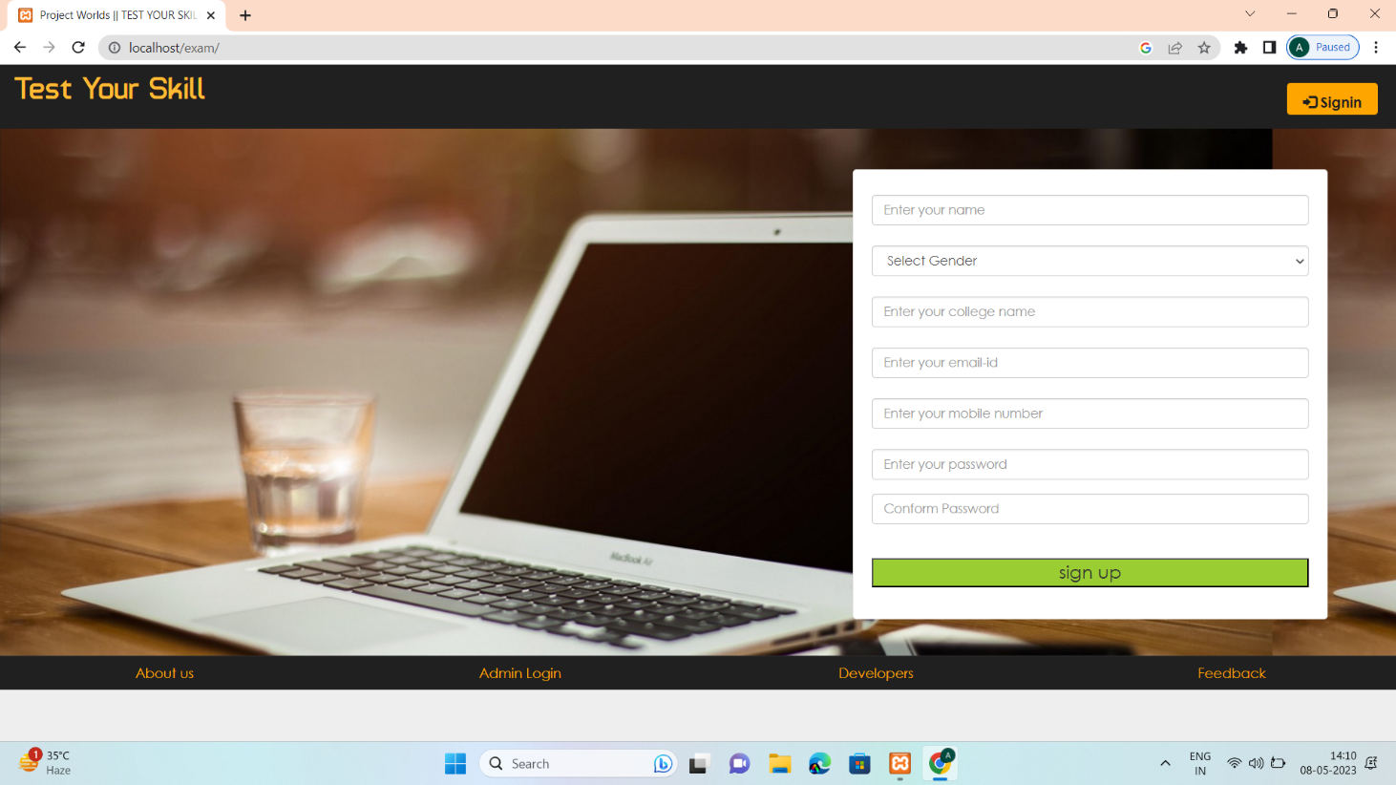

Figure:3

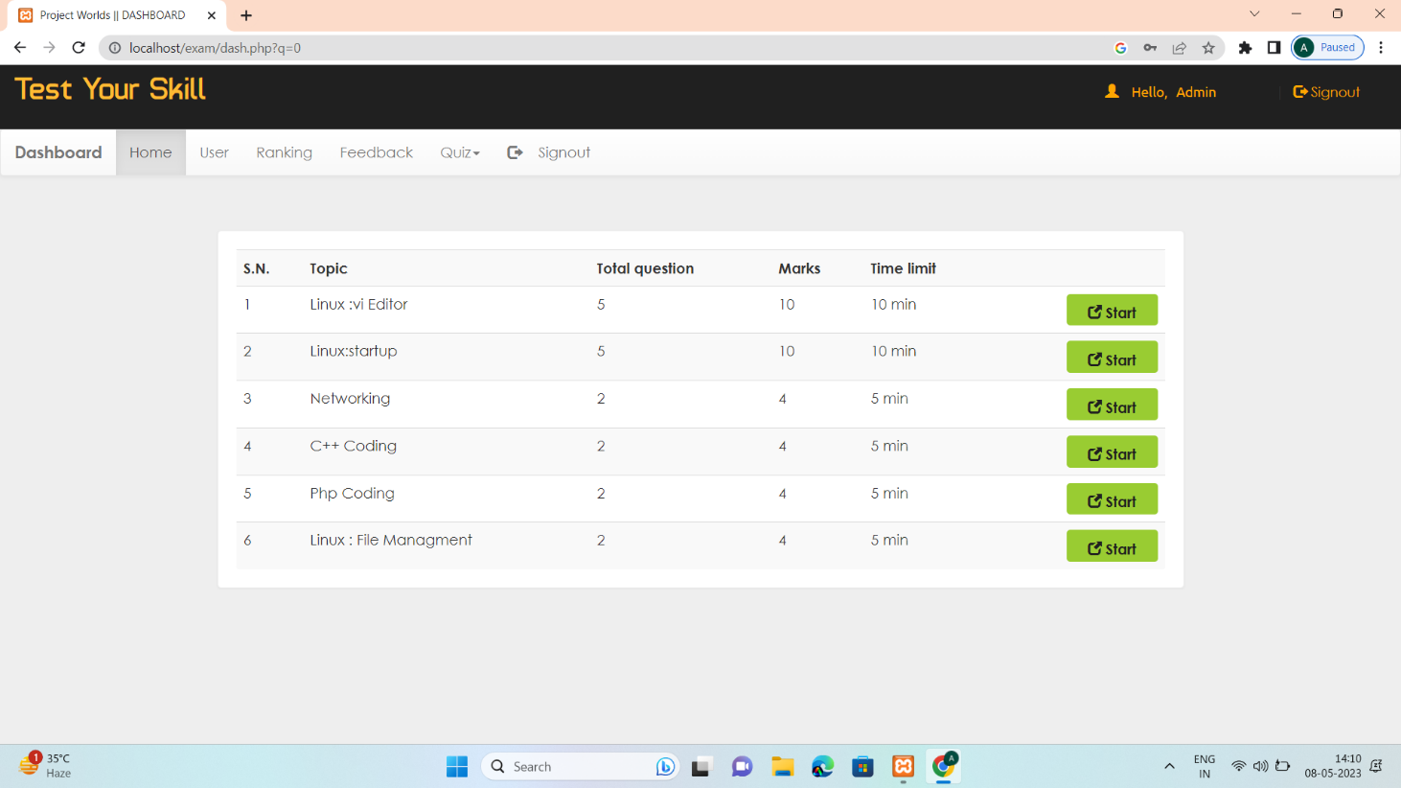

Figure:4

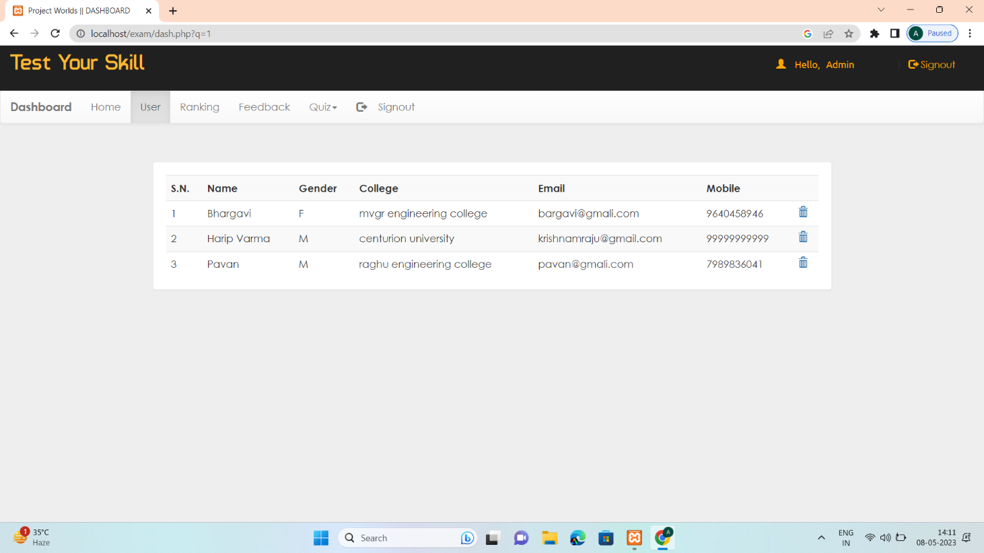

Figure:5

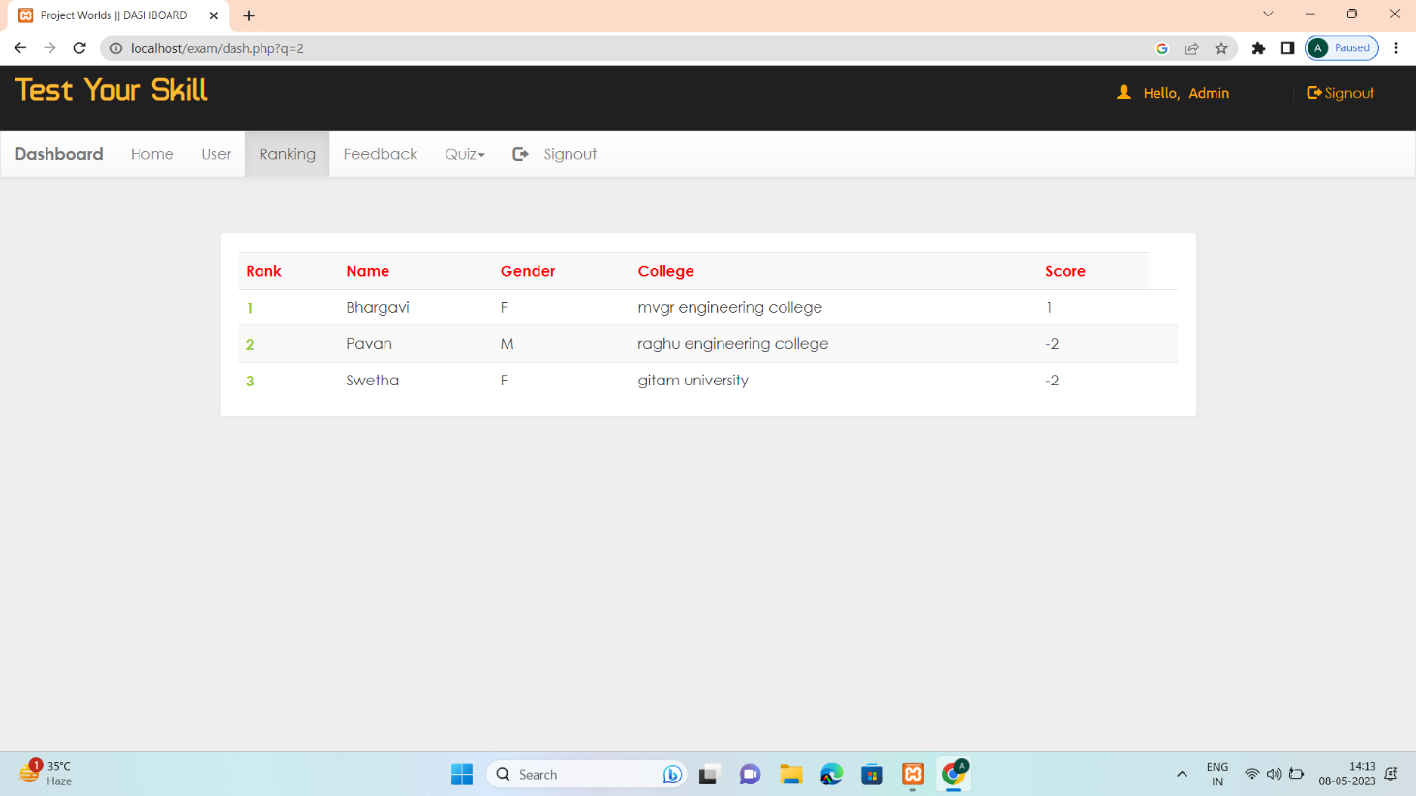

**Figure:6**

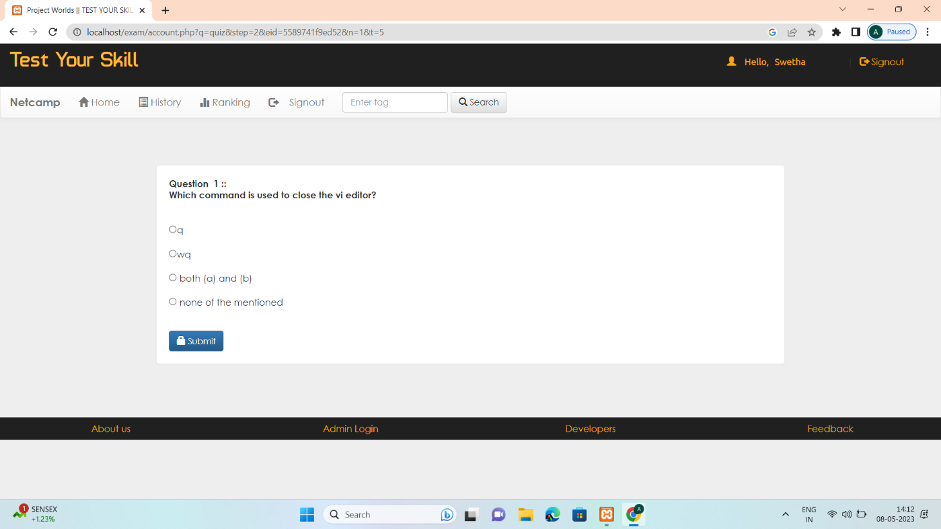

**Figure:7**

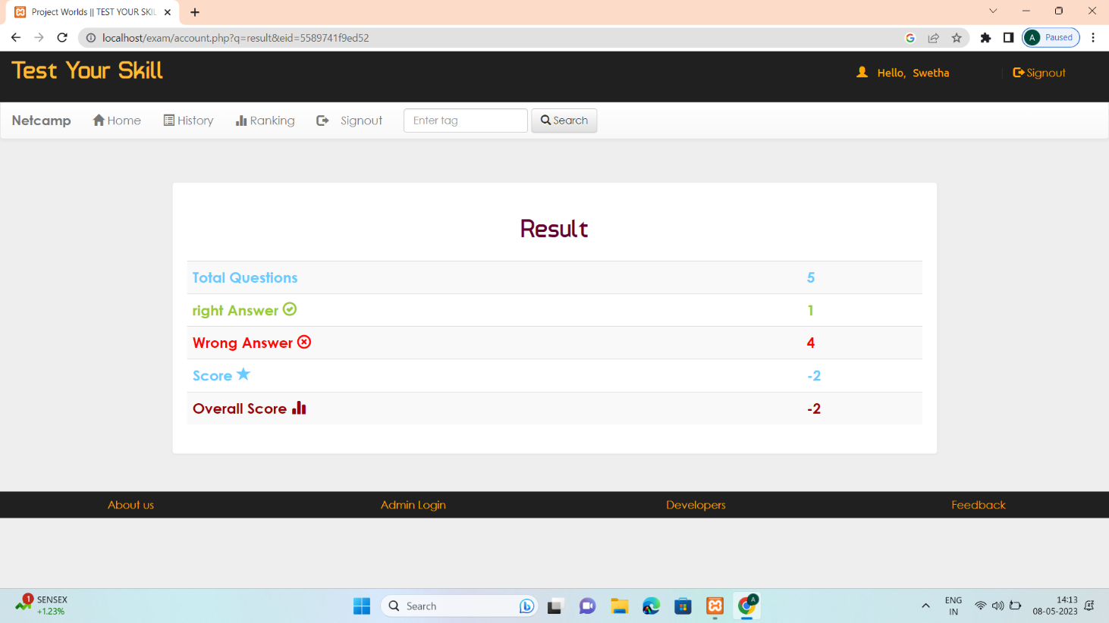

**Figure:8**

## 2.2 Product functions

#### 2.2.1 Context Diagram

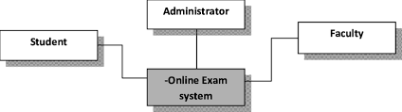

Figure 1: Context Diagram

#### 2.2.2 Use Case Diagrams

###### 2.2.2.1 User Login

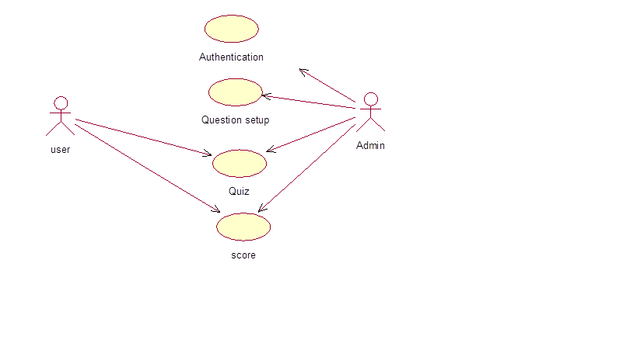

**Figure 1: User Login**

#### 2.2.3 Use case descriptions /Introductions

**2.2.3.1 User Registration:**

Users can create an account on the online quiz system by providing their personal information and credentials. They can register using their email addresses or through integration with other authentication methods, such as Google or Facebook. The system verifies the information and creates a unique user profile for each user.

**2.2.3.2 Quiz Creation:**

Educators can create quizzes by selecting the appropriate subject, topic, and difficulty level. They can add multiple-choice, true/false, or open-ended questions to the quiz. Educators can also set time limits, assign weights to questions, and define grading criteria. Once created, the quiz is saved in the system and can be assigned to students.

**2.2.3.3 Quiz Assignment**:

Educators can assign quizzes to specific classes or individual students. They can set deadlines and specify any additional instructions or resources. Students receive notifications about the assigned quizzes and can access them through their accounts. The system ensures that students can only access the quizzes they are assigned to.

**2.2.3.4 Quiz Taking:**

Students can access assigned quizzes through their accounts. They can view and answer each question within the given time limit. The system provides a user-friendly interface for students to navigate through the questions, select options, and submit their answers. The system tracks the time taken for each question and overall quiz completion.

**2.2.3.5 Automated Grading:**

After students submit their quizzes, the system automatically grades multiple-choice and true/false questions. It compares the student's answers with the correct ones and calculates the scores accordingly. The system applies predefined grading rules, such as assigning points for correct answers and deducting points for incorrect ones. The graded quizzes are then available for review.

**2.2.3.6 Manual Grading:**

For open-ended or subjective questions, educators can manually review and grade student responses. The system provides an interface for educators to view and evaluate each student's answers. Educators can provide comments or feedback and assign scores based on their evaluation. The system calculates the final scores by combining the automated and manual grading components.

**2.2.3.7 Quiz Review:**

After a quiz is graded, students can review their submitted answers and compare them with the correct answers. The system displays the scores achieved and provides feedback or explanations for each question. This allows students to understand their strengths and areas for improvement, enhancing the learning process.

**2.2.3.8 Performance Analytics**:

The system provides performance analytics and reports for educators to track student progress and identify trends. Educators can view class-wide or individual student performance statistics, such as average scores, question-wise analysis, and time taken per question. These analytics help educators assess teaching effectiveness and adjust instructional strategies as needed.

**2.2.3.9 System Administration:**

Administrators have access to system administration features. They can manage user accounts, roles, and permissions. They can also configure system settings, such as default grading criteria, email notifications, and system updates. Administrators ensure the smooth operation and maintenance of the online quiz system.

These use cases illustrate various scenarios and interactions within an online quiz system, involving different actors and their roles. They cover the main functionalities of the system, from user registration to quiz creation, assignment, taking, grading, and performance analysis.

**2.3 User characteristics**

**2.3.1 Student:**

The user characteristics of students in an online quiz system may vary depending on various factors such as age, academic level, cultural background, technological proficiency, and motivation. Some common user characteristics of students in an online quiz system include:

Age: Students from different age groups may have different levels of comfort and familiarity with technology, which can impact their ability to use an online quiz system effectively.

Academic Level: The academic level of students, such as elementary, middle, high school, or college, can affect their proficiency in using an online quiz system and their ability to understand and answer quiz questions

## 2.4 Constraints

#### 2.4.1 User Interface Constraints

Using this system is fairly simple and intuitive. A user familiar with basic browser navigation skills should be able to understand all functionality provided by the system.

#### 2.4.2 Hardware Constraints

The system should work on most home desktop and laptop computers which support JavaScript and HTML5.

#### 2.4.3 Software Constraints

The system will be intended to run on and above, Google Chrome 10 and above and Internet Explorer 8 and above.

#### 2.4.4 Data Management Constraints

System shall be able to interface with other components according to their specifications.

#### 2.4.5 Operational Constraints

The system is limited by its operating server in terms of the maximum number of users it can support at a given time.

#### 2.4.6 Site Adaptation Constraints

The component will be adapted to the overarching system at the conclusion of the system creation.

#### 2.4.7 Design Standards Compliance

The system shall be implemented in java script and html.

### **2.5 Assumptions and dependencies**

Most of the academic portals have a lot of redundant features which are rarely used in an academic sessions. Our new system focuses on the features which are most important to the users of an academic institute along with introduction of some new features .

### **2.6 Apportioning of Requirements**

### Visual studio ,mysql.

# 3. Specific Requirements

## 3.1 External interface

#### 3.1.1 Web Server

* Apache will be used as web server:
* The user inputs data via the web server using HTML forms
* The web server executes the PHP as a module and PHP script retrieves the post data if available.
* The web server receives information back from the PHP script. • The web server displays a HTML page as result to the end-user.

#### 3.1.2 PHP Application

The actual program that will perform the operations is written in PHP. All data will be stored in a database.

#### 3.1.3 MySQL Database

It’s an open source SQL database to store all data which communicates with the application on the server.

## 3.2 Functional Requirements

#### 3.2.1 Use Case Scenario

###### 3.2.1.1 Use Case Scenario 1 – User Login

User Login

The user login process is a fundamental step in accessing an online quiz system. Here is a description of the typical user login process:

User Interface: The online quiz system presents a login page where users can enter their credentials to access their accounts. The login page may include fields for the username or email address and password.

User Input: Users enter their registered username or email address and the corresponding password in the provided fields. They may also have the option to select a "Remember Me" checkbox for automatic login in future sessions.

###### 3.2.1.2 Use Case Scenario 2 – quiz taking(Upload Files)

A user logs into the system and is on any page and wants to get into the next step. User Registration and Login:

a. Students register on the online quiz system by providing their personal information and credentials.

b. Students log in to their accounts using their registered username/email and password.

Quiz Taking:

a. Students access their assigned quizzes through their accounts.

b. They read each question and select or enter their answers within the given time limit.

c. The system tracks the time taken for each question and overall quiz completion.

###### 3.2.1.3 Use Case Scenario 3 – automated grading

a. Multiple-choice and true/false questions are automatically graded by the system.

b. The system compares the student's answers with the correct ones and calculates scores accordingly.

c. Grading rules, such as assigning points for correct answers and deducting points for incorrect ones, are applied Discussion Thread

###### 3.2.1.4 Use Case Scenario 4 – review

Quiz Review:

a. After grading, students can review their submitted answers.

b. They can compare their answers with the correct ones and view the scores achieved.

c. Feedback or explanations for each question may be provided to aid learning and improvement.

## 3.3 Performance Requirements

The system should support at least 200 concurrent users.

This statement provides a general sense of reliability when the system is under load. It is important that a substantial number of users be able to access the system at the same time,. The times when the system will be under the most stress are likely during more user logins at a time. Therefore, it must be able to handle at least 200 concurrent users.

## 3.4 Logical database requirements

All data will be saved in the database: user accounts and profiles, discussion data, messages etcThe database allows concurrent access and will be kept consistent at all times, requiring a good database design.

## 3.5 Design Constraints

1. The communication between the portal software and the database will be in SQL.
2. The portal layout will be produced with HTML/CSS.
3. The product will be written injavascript.
4. The output must be compatible with W3C XHTML 1.0
5. The source code must follow the coding conventions of javascript.
6. System administrators must have access to comprehensive documentation.

## 3.6 Software System Attributes

The software consists of the following elements:

1. The apache web server
2. The javascript application
3. The MySQL database
4. The database should remain consistent at all times in case of an error.